Master Functional Document

Application | NGERP - Centra
Service Bundle | Master Management
Service Request | Tenant

Description :

Tenant is used to monitor all the functions in the NGERP application.

Workflow Process :

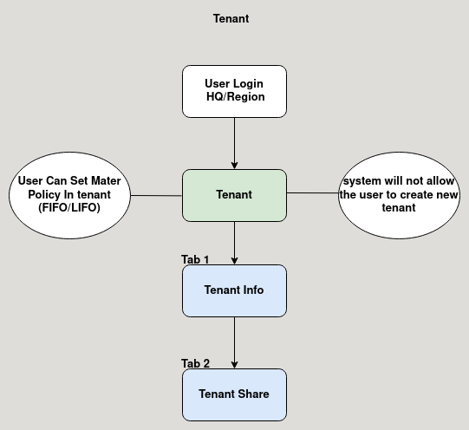

Business Rules :

- User can login to HQ or Region to view tenant.
- User cannot able to create new tenant.
- User can set material policy in tenant master (FIFO/ LIFO).
- Tenant info tab shows the tenant information.

